**USA**

5* New York – 3 nights From £739pp 5* Las Vegas – Aria Hotel From £629pp



4* Miami Beach From £649pp 5* Hawaii – 7 nights From £1,439pp

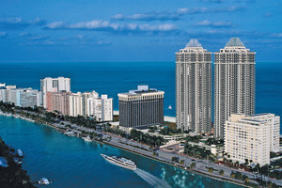

4* Los Angeles From £799pp 5* Orlando From £849pp

